

**FOOTBALL CLUB**

**MANAGEMENT SYSTEM**

**COURSE:** INTRODUCTION TO DATABASE

**SECTION:** F

**COURSE TEACHER:** JUENA AHMED NOSHIN



|  |  |
| --- | --- |
| GROUP MEMBERS: | |
| **ID:** | **NAME:** |
| 17-35559-3 | RAFA,FAHMIDA ALAM |
| 17-35610-3 | OSMAN,TANJINA |
|  | DEBNATH,DURJOY |
| 17-35526-3 | KARMAKAR,JOYDEB |

**CONTENTS:**

* INTRODUCTION
* SCENARIO DESCRIPTION
* E-R DIAGRAM
* NORMALIZATION
* TABLE CREATION
* DATA INSERTION
* QUERY WRITING
* CONCLUSION

**Introduction**

Football, as we know is an extremely popular sport, played by millions around the world. It’s a great way of staying active, forming new friendship and building a new community.

With such wide-spread love and support for the game, it’s assumed that setting up a new team or club is an easy task. But If it is setting an own club, It’s a lot more work than it sounds.

Before become an established, successful club there are plenty of things you need to consider in order to make it happen.

**Football Club Management System**

* A football club president wants to make a database system for the club. In that management system football club will identified by it’s registration number and the name of that club will also be stored. The football club has some responsible members. Responsible members will identified by their ID and name, post, salary, email, address, multivalued phone number will also stored. Responsible members will select exactly one president. The president will identified by his ID, name, salary, email, address, multivalued phone number will stored in database. The football club has a team. Team will be identified by it’s ID, name and rank will be stored. The football club has players. Players will be identified by their ID, name, birthdate, height, weight, multivalued skill, phone number, hire-date, nationality, salary will be stored in database. Players play exactly for one team. The president will hire exactly one coach to train players. Coach will identified by his ID, name, email, phone number, nationality, hire-date, salary will be stored. The president will also hire some medical stuff to provide treatment to players. Medical stuff will be identified by their ID, name, address, salary, hire-date, phone number, email will be stored. The football club has exactly one stadium. The stadium will identified by it’s registration id, name, place will also be stored. The stadium has a showcase to display trophies. Showcase will identified by it’s ID, name. Trophy will be identified by ID, name. The president will hire some stuff to maintain stadium. Stuff will be identified by their ID, name, email, phone number, address, salary, hire-date will also stored in database management system.

**Diagram**

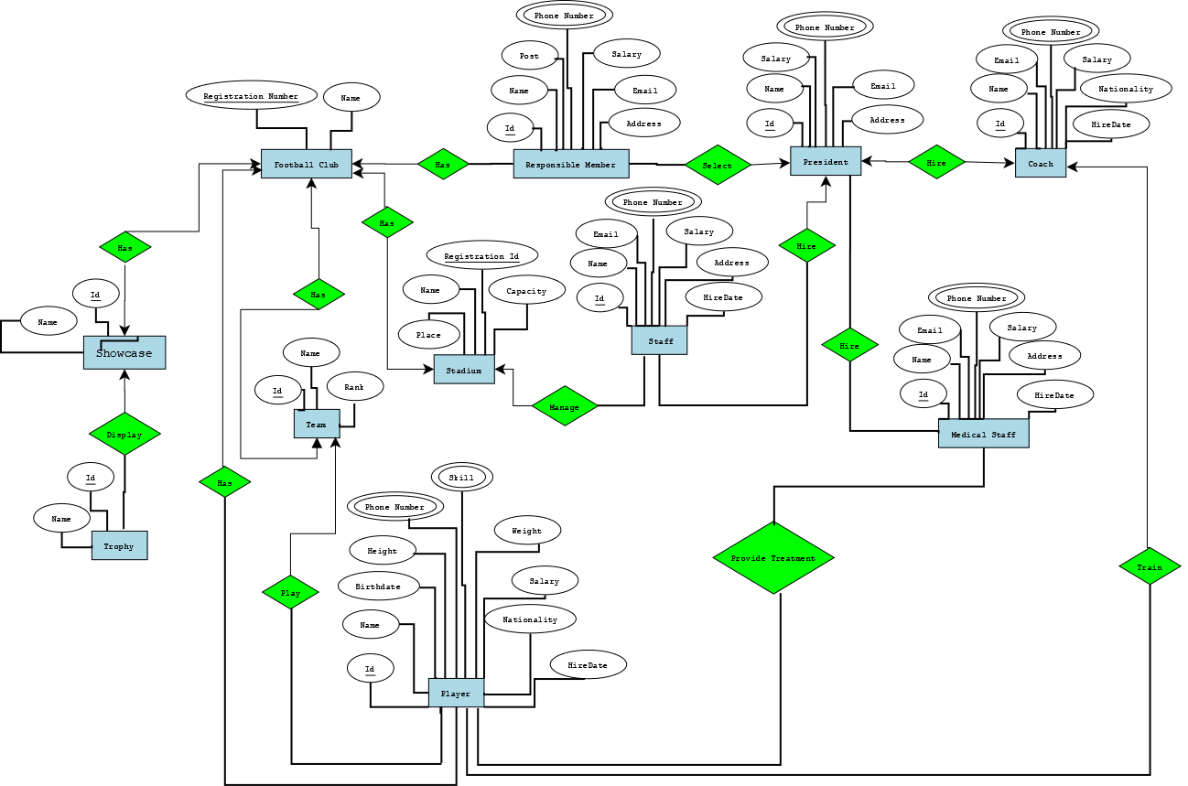

**Normalization**

**Football club--Has--Responsible Member**

**UNF:**

Has(Fc_registration_number,Fc_name,RM_ID,RM_name,post, phone,salary,email,address)

**1NF:**

Phone number is a multivalued attribute.

1. (Fc_Registration_number,Fc_name,RM_ID,RM_name,post,phone, salary,email,address)

**2NF:**

1. (Fc_Registration_number,Fc_name)
2. (RM_ID,RM_name,post,phone,salary,email,address)

**3NF:**

1. (post,salary)

2. (RM_ID,RM_name,phone,email,address)

3. (Fc_name,Fc_Registration_number)

**Table Creation:**

1. (A_id, post, salary)

2.(RM_id,RM_name,phone,email,address, **A_ID**)

1. (Fc_name,Fc_Registration_number)
2. ~~(RM_ID, Fc_Registration_number)~~

**Responsible Member--select—President**

**UNF:**

Select(RM_ID,RM_name,post,phone,salary,email,address,p_id,p_name,salary,phone,email,address)

**1NF:**

Phone number is a multivalued attribute.

1.(RM_ID,RM_name,post,phone,salary,email,address,p_id,p_name,salary,phone,email,address)

**2NF:**

1.(RM_ID,RM_name,post,phone,salary,email,address)

2.( p_id,p_name,salary,phone,email,address)

**3NF:**

1.(post,salary)

2.(RM_ID,RM_name,phone,salary,email,address)

3.(p_id,p_name,salary,phone,email,address)

**Table Creation:**

1.(A_ID,post,salary)

2.(RM_ID,RM_name,phone,email,address,**p_id** ,**A_ID**)

3.(p_id,p_name,salary,phone,email,address)

**President --Hire—Coach**

**UNF:**

Hire(p_id,p_name,salary,phone,email,address,c_id,c_name, email,phone,salary,nationality,hiredate)

**1NF:**

Phone number is a multivalued attribute.

1.(p_id,p_name,salary,phone,email,address,c_id,c_name, email,phone,salary,nationality,hiredate)

**2NF:**

1. (p_id,p_name,salary,phone,email,address)

2. (c_id,c_name, email,phone,salary,nationality,hiredate)

**3NF:**

1. (c_id,c_name, email,phone,salary,nationality,hiredate)

2. (p_id,p_name,salary,phone,email,address)

**Table creation:**

1. ~~(A_id,salary,hiredate)~~

2. (p_id,p_name,salary,phone,email,address,**c_id**)

3. (c_id,c_name, email,phone,salary,nationality,hiredate)

**Football club--Has—Showcase**

**UNF:**

Has(Fc_Registration_number,Fc_name,sc_name,sc_id)

**1NF:**

There is no multivalued attribute.

1. (Fc_Registration_number,Fc_name,sc_name,sc_id)

**2NF:**

1. (Fc_Registration_number,Fc_name)
2. (sc_name,sc_id)

**3NF:**

1. (sc_name,sc_id)

2. (Fc_Registration_number,Fc_name)

**Table Creation:**

1. (Fc_Registration_number,Fc_name**, sc_id**)

2. (sc_name,sc_id)

**Showcase--Display--Trophy**

**UNF:**

Display(sc_id,sc_name,t_id,t_name)

**1NF:**

There is no multivalued attribute.

1. Display(sc_id,sc_name,t_id,t_name)

**2NF:**

1.(sc_id,sc_name)

2.( t_id,t_name)

**3NF:**

1.(t_id,t_name)

2.(sc_id,sc_name)

**Table Creation:**

1.(sc_id,sc_name,**t_id**)

2.(t_id,t_name)

**Football club--Has—Player**

**UNF:**

Has(Fc_Registration_number,Fc_name,p_id,p_name,birthdate,height,phone,skill,weight,salary,nationality,hiredate)

**1NF:** Phone number and skill are multivalued attribute.

1.(Fc_Registration_number,Fc_name,p_id,p_name,birthdate,height,phone,skill,weight,salary,nationality,hiredate)

**2NF:**

1.(Fc_Registration_number,Fc_name)

2.(p_id,p_name,birthdate,height,phone,skill,weight,salary,nationality,hiredate)

**3NF:**  
1.(salary,skill)

2.(p_id,p_name,birthdate,height,phone,skill,weight,salary,nationality,hiredate)

3. (Fc_Registration_number,Fc_name)

**Table Creation:**

1.(A_id,salary,skill)

2.(p_id,p_name,birthdate,height,phone,skill,weight,salary,nationality,hiredate,A_id)

3.(Fc_Registration_number,Fc_name,p_id,p_name,birthdate,height,phone,skill,weight,salary,nationality,hiredate)

**Football club--Has—Team**

**UNF:**

Has(Fc_Registration_number,Fc_name,t_id,t_name,rank)

**1NF:**

There is no multivalued attribute.

1.(Fc_Registration_number,Fc_name,t_id,t_name,rank)

**2NF:**

1.(Fc_Registration_number,Fc_name)

2. (t_id,t_name,rank)

**3NF:**

1.(t_id,t_name,rank)

2.(Fc_Registration_number,Fc_name)

**Table Creation:**

1.(Fc_Registration_number,Fc_name,**t_id**)

2.(t_id,t_name,rank)

**Team ----- play ----playe**r

**UNF:**

Play (Player name, Birthdate, Height, Phone number, Skill, Weigh, Salary, Nationality, Hire date, T-id, T-name, rank )

**1NF:**

Phone number and skill are multivalued attribute

1. (P-Id, p-name, birthdate , height, phone number , skills , weight ,salary, nationality , hire date ,T-id , T-name, rank )

**2NF:**

1. (P-Id, P-name, birthdate , height, phone number , skills , weight ,salary, nationality , hire date)
2. (T-id, T-name, rank )

**3NF:**

1. (skills, salary)
2. (player name, birthdate , height, phone number , weight , nationality , hire date)
3. (T-id, T-name, rank )

**Table creation:**

1. (A-Id, skill ,salary)
2. (player-id, p-name, birthdate, height , phone number, weight , nationality, Hire-date, **A-Id** ,**T-Id** )
3. (T-Id, T-name, rank)

**Football-----club---- has ----stadium**

**UNF:**

Has (Fc-registration Number, Fc-name, St-name, place, St-registration Id, capacity)

**1NF:**

There is no multivalued attribute.

1. ( Fc-registration Number, Fc-name, St-name, place, St-registration Id, capacity)

**2NF:**

1. ( Fc-registration Number, Fc-name)
2. (St-name, place, St-registration Id, capacity)

**3NF:**

1. (St-name, place, St-registration Id, capacity)
2. ( Fc-registration Number, Fc-name)

**Table creation:**

1. ( Fc-registration Number, Fc-name, , **St-registration Id**)
2. (St-name, place, St-registration number , capacity)

**Stadium------Manage-------Staff**

**UNF:**

Manage (St-name, place, st-registration id ,capacity ,St-Id ,S-name , Email, phone number, salary , address , hire date)

**1NF:**

Phone number is a multivalued attribute.

1. (St-name , place , St-registration id , capacity , St-Id ,S-name, Email, phone number, salary , address , hire date)

**2NF:**

1. (St-name, place, Registration Id, Capacity)
2. (S-Id, S-name, Email, phone number, salary , address , Hire date)

**3NF:**

1. S-Id, S-name, Email, phone number, salary , address , Hire date)
2. (St-name, place, Registration Id, Capacity)

**Table Creation:**

1. (St-name, place, Registration Id, Capacity , **S-Id** )
2. (S-Id , S-name, Email, phone number, salary , address)

**Staff----Hire-----President**

**UNF:**

Hire (S-Id , S-name, Email , Phone number ,salary , address, Hire date , P-Id , P-name , salary , phone number, email, Address)

**1NF:**

Phone number is a multivalued attribute.

1. (S-Id , S-name, Email , Phone number ,salary , address , Hire date , P-Id , P-name , salary , phone number, email, Address)

**2NF:**

1. (S-Id , S-name, Email , Phone number ,salary , address , Hire date)
2. (P-Id , P-name , salary , phone number, email, Address)

**3NF:**

1. (P-Id , P-name , salary , phone number, email, Address)
2. (S-Id , S-name, Email , Phone number ,salary , address , Hire date)

**Table Creation:**

1. (S-Id , S-name, Email , Phone number ,salary , address , Hire date, **P-Id** )
2. (P-Id , P-name , salary , phone number, email, Address)

**President ------- Hire-----Medical staff**

**UNF:**

Hire (P-Id, P-name, salary, phone number, Email, Address, Ms-Id , Ms-name, Email, phone number, salary, address, Hire date)

**1NF:**

Phone number is a multivalued attribute

1. (P-Id, P-name, salary, phone number, Email, Address, Ms-Id, Ms-name, Email, phone number, salary, address, Hire date)

**2NF:**

1. (P-Id, P-name, salary, phone number, Email, Address)
2. (Ms-Id , Ms-name, Email, phone number, salary, address , Hire date)

**3NF:**

1. (Ms-Id , Ms-name, Email, phone number, salary, address, Hire date)
2. (P-Id, P-name, salary, phone number, Email, Address)

**Table Creation:**

1. (P-Id, P-name, salary, phone number, Email, Address)
2. (Ms-Id , Ms-name, Email, phone number, salary, address, Hire date , **P-Id**)

**Medical Staff--Provide treatment--player**

**UNF:**

Provide treatment (Ms-Id ,Ms-name, Email, Phone number, Salary , Address ,Hire date, P-Id , P-name, Birthdate, Height, Phone number , skill, weight salary, Nationality , Hire date)

**1NF:**

Phone number and skill are multivalued attribute.

1. (Ms-Id ,Ms-name, Email, Phone number, Salary , Address , Hire date, P-Id , P-name, Birthdate, Height, Phone number, skill, weight salary, Nationality , Hire date)

**2NF:**

1. (Ms-Id ,Ms-name, Email, Phone number, Salary, Address, Hire date)
2. (P-Id , P-name, Birthdate, Height, Phone number ,skill, weight, salary, Nationality , Hire date)

**3NF:**

1. (Skill, Salary)
2. (P-Id , P-name, Birthdate, Height, Phone number , skill, weight salary, Nationality , Hire date)
3. (Ms-Id ,Ms-name, Email, Phone number, Salary , Address , Hire date)

**Table Creation:**

1. (A-Id, skill, salary)
2. (P-Id , P-name, Birthdate, Height, Phone number , weight, Nationality , Hire date, **A-Id** )
3. (Ms-Id ,Ms-name, Email, Phone number, Salary , Address , Hire date)
4. ( **P-Id** , **Ms-Id** )

**Coach----Train---Player**

**UNF:**

Train (C-Id , C-name, Email, Phone number , salary ,Nationality, Hire date, P-Id , P-name, Birthdate, Height , Phone number, Skill, Weight, Salary, Nationality , Hire date)

**1NF:**

Phone number and skill are multivalued attribute.

1. (C-Id , C-name, Email, Phone number , salary ,Nationality, Hire date, P-Id , P-name, Birthdate, Height , Phone number, Skill , Weight, Salary, Nationality , Hire date)

**2NF:**

1. (C-Id, C-name, Email, Phone number , salary ,Nationality, Hire date)

1. ( P-Id , P-name, Birthdate, Height , Phone number, Skill , Weight, Salary, Nationality , Hire date)

**3NF:**

1. (skill, salary)
2. ( P-Id , P-name, Birthdate, Height , Phone number , Weight, Nationality , Hire date)
3. (C-Id , C-name, Email, Phone number , salary ,Nationality, Hire date)

**Table Creation:**

1. ( A-Id , Skill , salary)
2. ( P-Id , P-name, Birthdate, Height , Phone number , Weight, Nationality , Hire date, **A-Id** , **C-Id** )
3. (C-Id , C-name, Email, Phone number , salary ,Nationality, Hire date)

**Table Creation**

**1.** (A_id,salary,post)

**2.** (RM_id,RM_name,phone,email,address,**p_id**,**a_id**)

**3**.(FC_Registration_number,FC_name,**sc_id,t_id st_registration_id**)

**4.** ( RM_id, FC_Registration_number)

**5.** (p_id,p_name,salary,phone,email,address,**c_id**)

**6.** (c_id,c_name,salary,phone,address,nationality,hiredate)

**7.** (sc_id,s_name,**t_id**)

**8.** (A_id,salary,skill)

**9**.(p_id,p_name,birthdate,phone,height,nationality,hiredate,**A_id, FC_Registration_number**)

**10.** (st_name,place,st_registration_id,capacity,**s_id**)

**11.** (s_id,s_name,email,phone,salary,address,hiredate,**p_id**)

**12.** (ms_id,ms_name,email,phone,salary,address,hiredate)

**13.** (**p_id,ms_id**)

**Query writing**

**1**.create table account(a_id number(20) primary key, post varchar2(20) not null, salary number(20) not null);

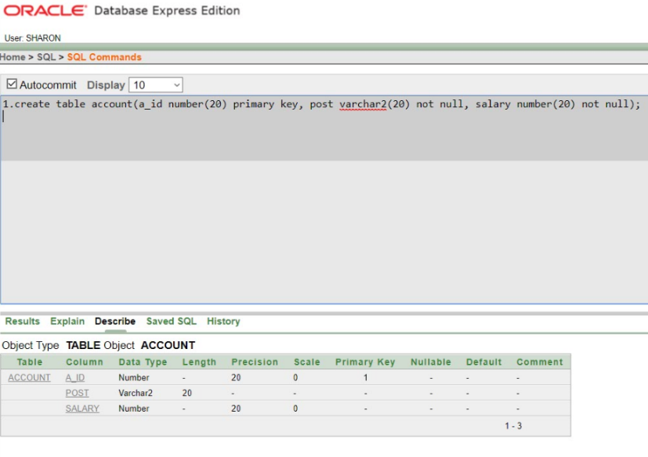

**2**.create table responsible_person(rm_id number(20) primary key, rm_name varchar2(20) not null, phone number(20) not null, email varchar2(20), address varchar2(30) not null,a_id number(20),p_id number(20));

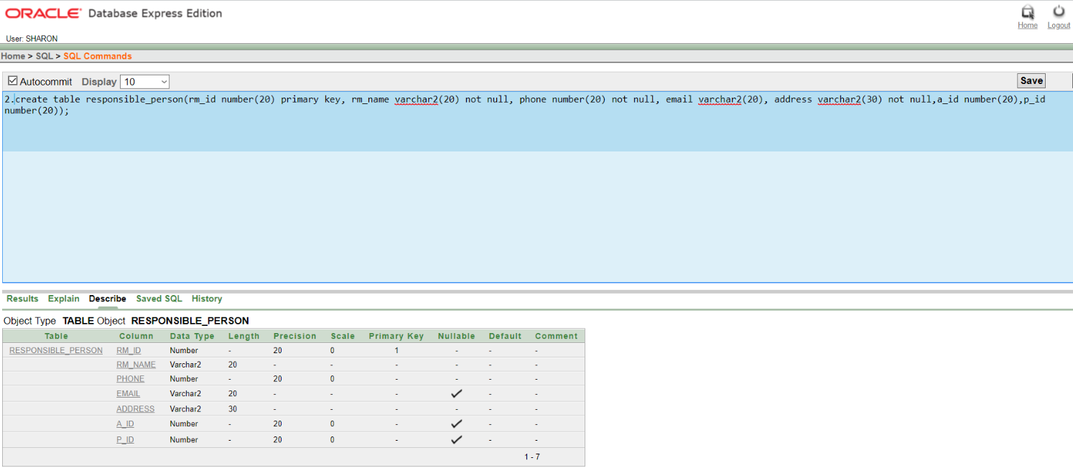

**3**.create table football_club(fc_registration_number number(20) primary key, fc_name varchar2(20) not null,sc_id number(20),t_id number(20),st_registration_id number(20));

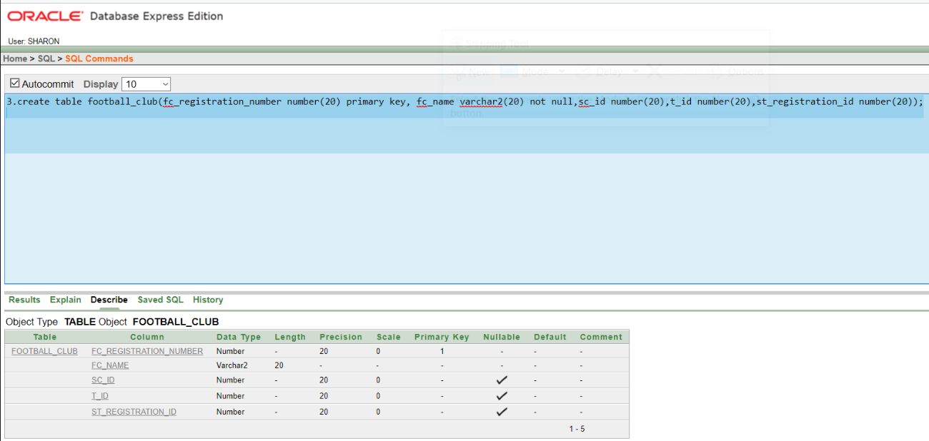

**4**.create table president(p_id number(20) primary key, p_name varchar2(20) not null, salary number(20) , phone number(20) not null unique , email varchar2(20) not null, address varchar2(20) not null,c_id number(20));

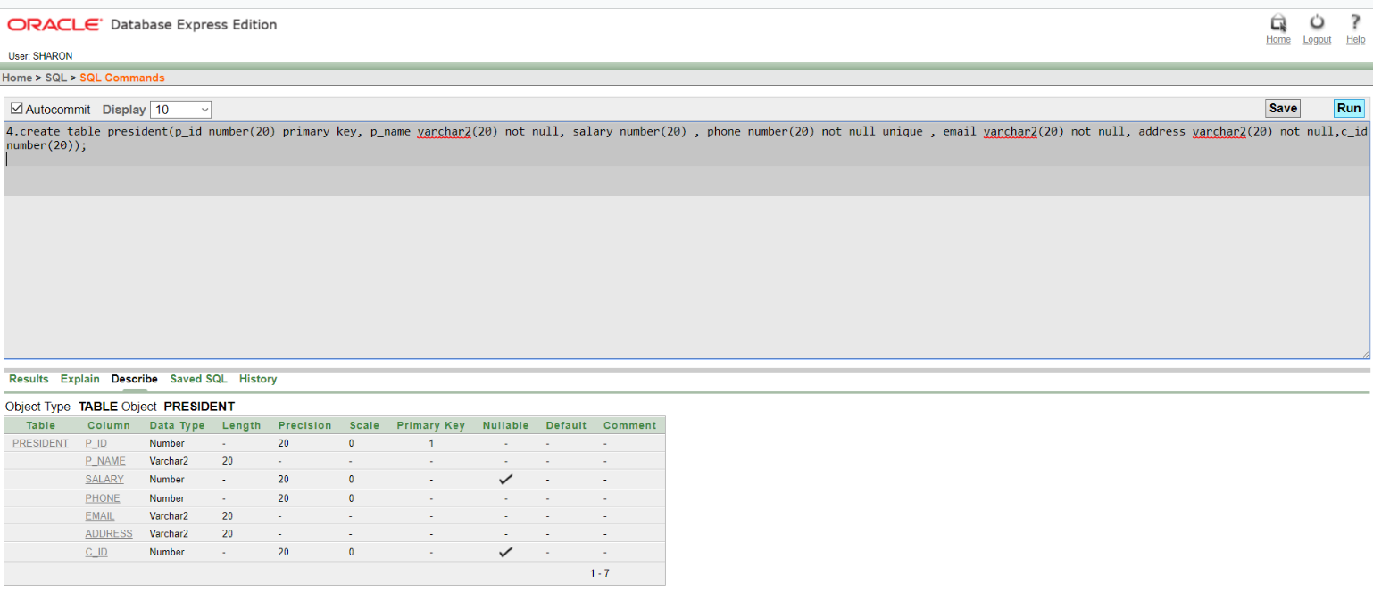

**5**.create table coach (c_id number(20) primary key, c_name varchar2(20) not null, salary number(20) , phone number(20) not null unique, address varchar2(20) not null, nationality varchar2(20), hiredate number(20) not null unique);

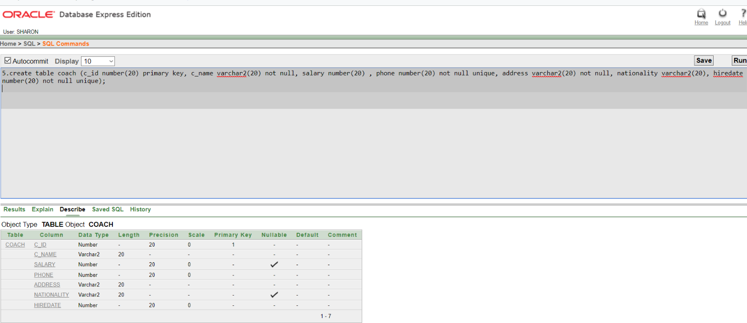

**6**.create table show_case (sc_name varchar2(20) not null, sc_id number(20) primary key,t_id number(20));

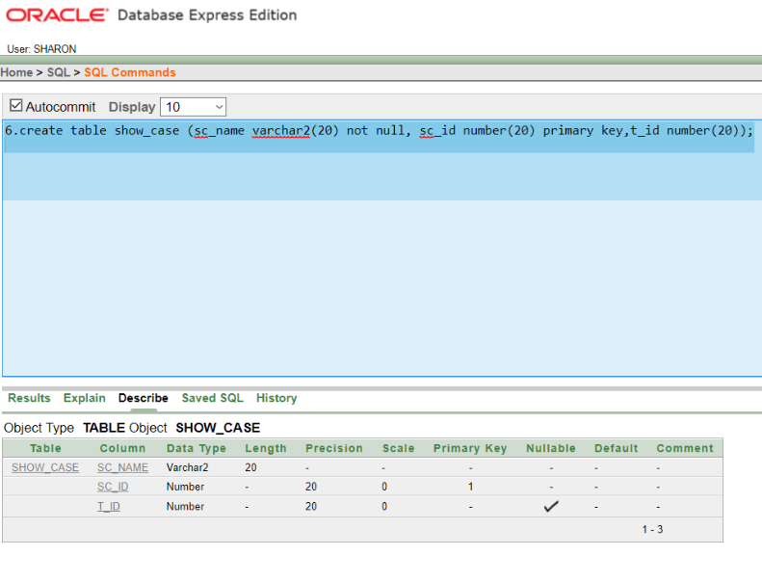

**7**.create table stadium (st_name varchar2(20) not null, place varchar2(20) not null, st_registration_id number(20) primary key, capacity number(20) not null,s_id number(20));

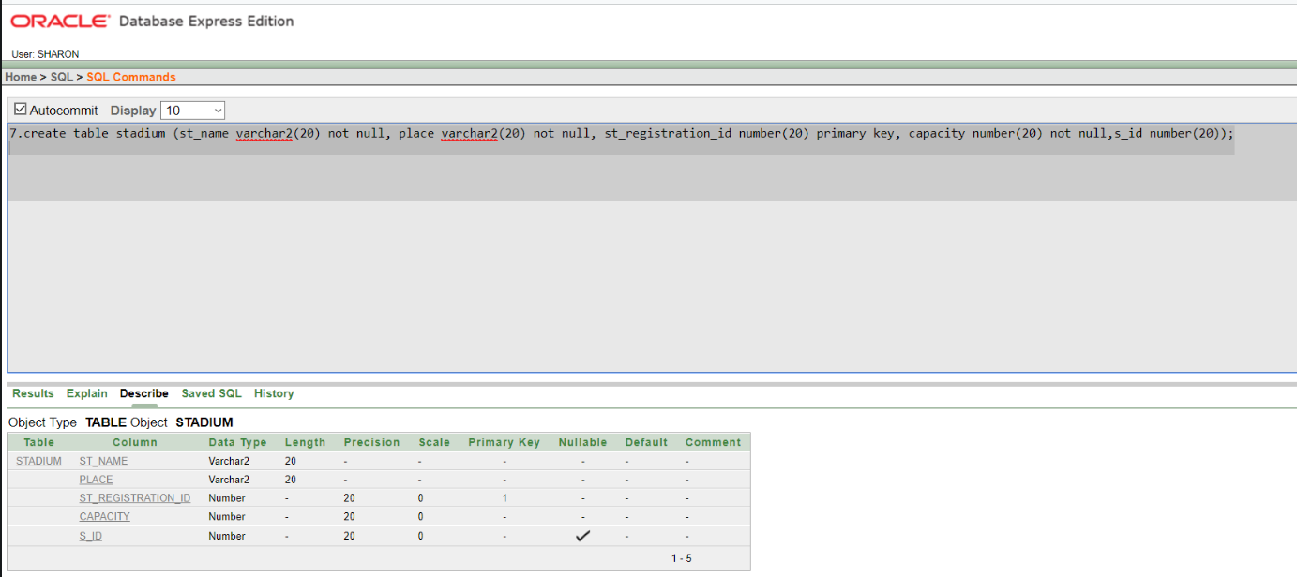

**8**.create table stuff (s_id number(20) primary key, s_name varchar2(20) not null, email varchar2(20) not null, phone number(20) not null, salary number(20) , address varchar2(20) not null, hiredate number (20) not null,p_id number(20));

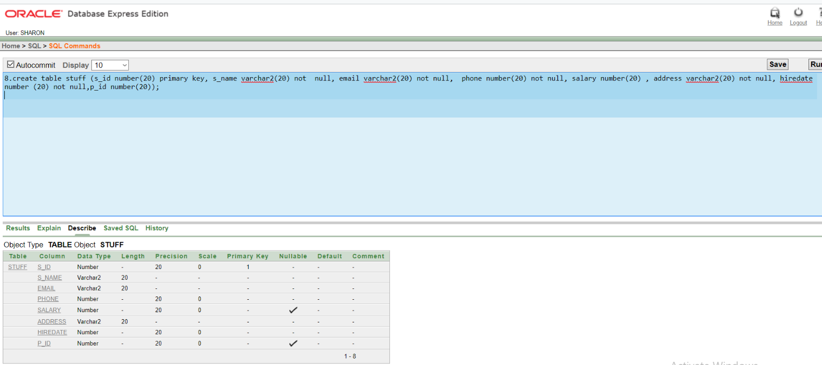

**9**.create table player_info1(a_id number(20) primary key, salary number(20) , skill varchar2(20) not null);

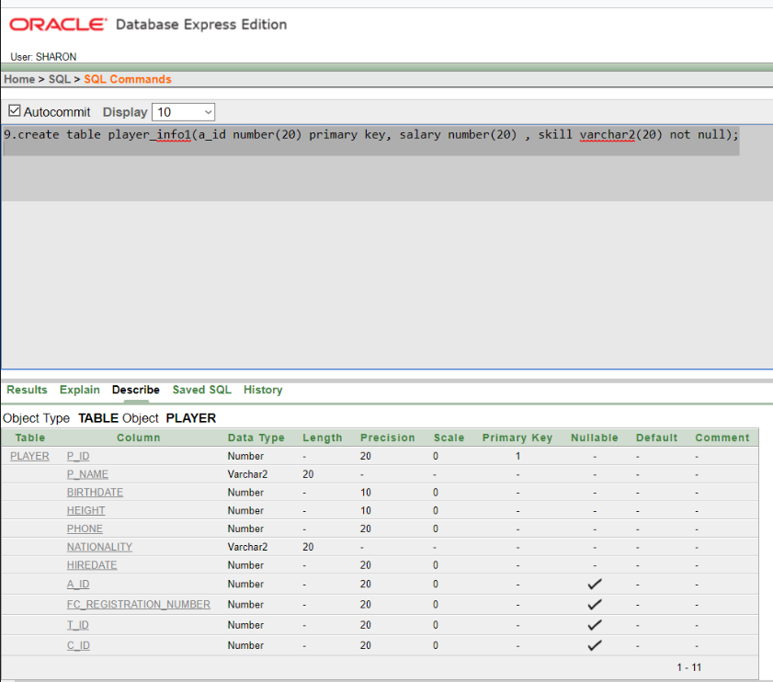

**10**.create table player(p_id number(20) primary key, p_name varchar2(20) not null, birthdate number(10) not null ,height number(10) not null, phone number(20) not null, nationality varchar2(20) not null, hiredate number(20) not null,a_id number(20),fc_registration_number number(20),t_id number(20),c_id number(20));

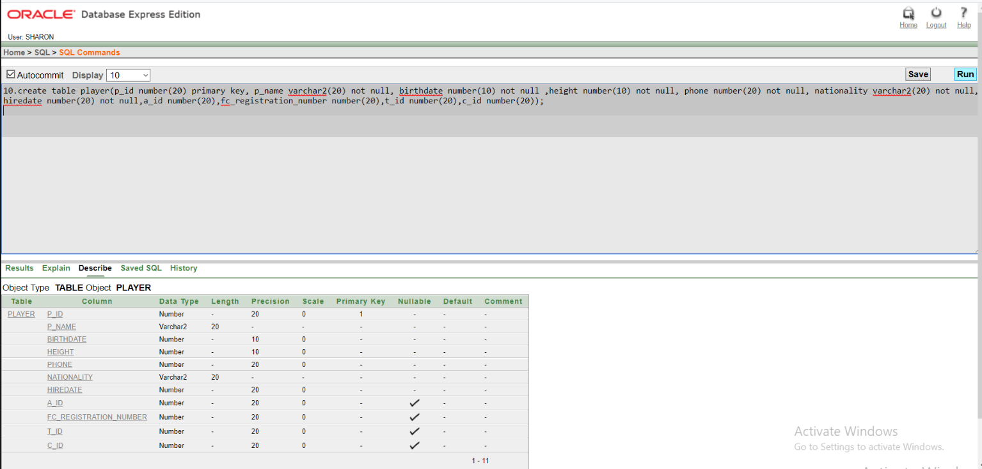

**11**.create table team(t_id number(20) primary key, t_name varchar2(20) not null, rank number(5));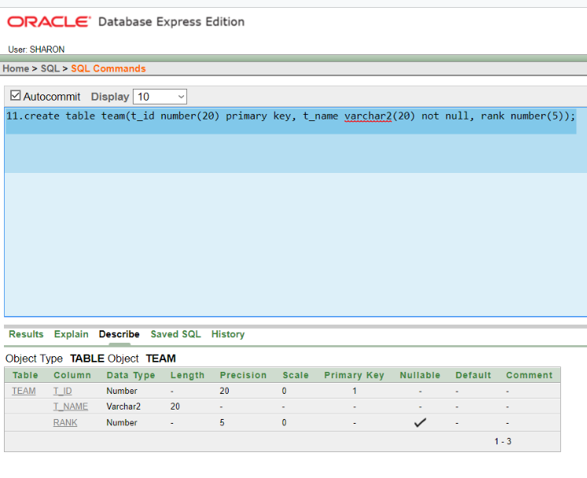

**12**.create table medical_staff (ms_id number(20) primary key, ms_name varchar2(20) not null, email varchar2(20) not null, phone number(20) not null, salary number(20), address varchar2(20), hiredate number(10));

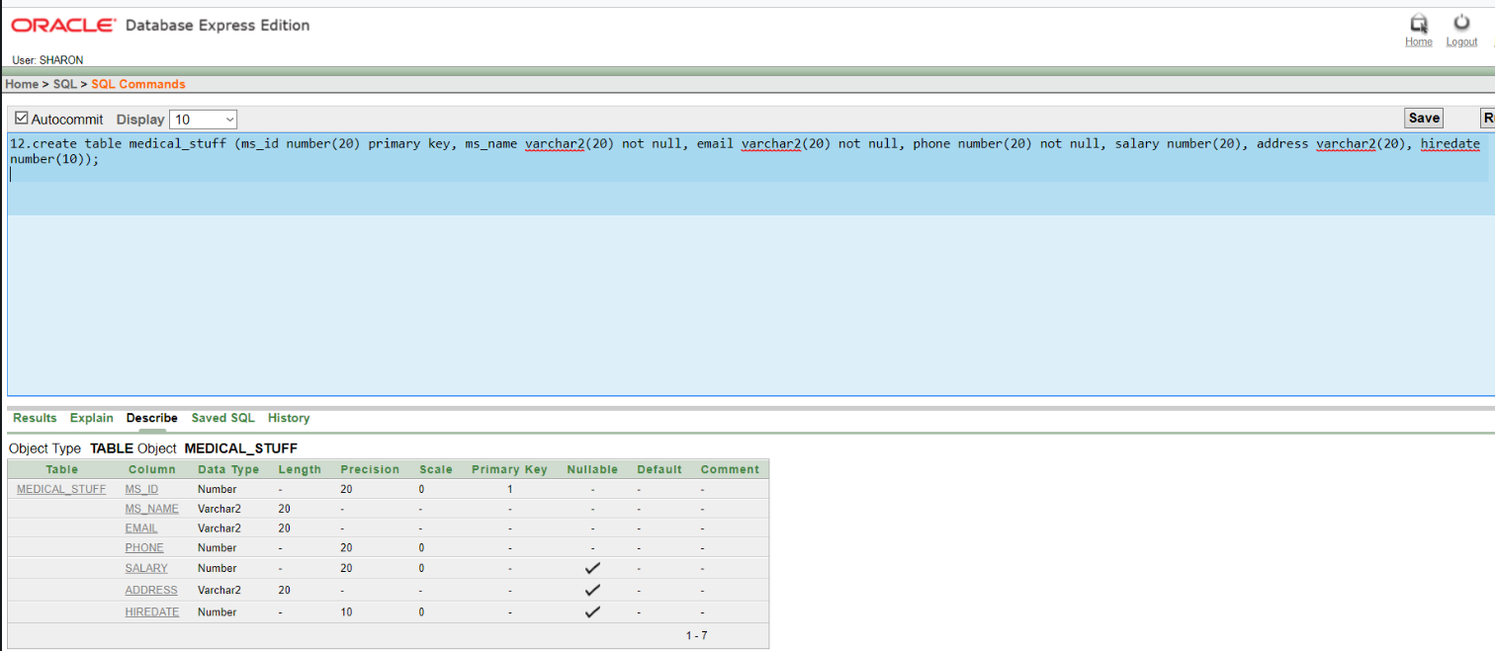

**13**.create table demo12(rm_id number(20) not null CONSTRAINT fkey11 REFERENCES responsible_person(rm_id), fc_registration_number number(20) not null CONSTRAINT fk435 REFERENCES football_club(fc_registration_number));

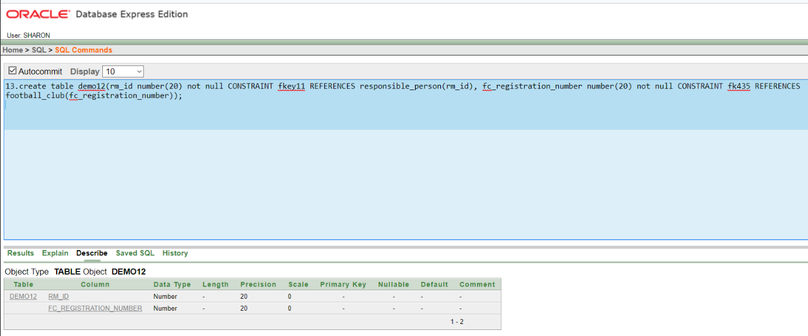

**14**.create table demo13 (p_id number(20) not null CONSTRAINT fk111 REFERENCES player(p_id), ms_id number(20) not null CONSTRAINT fkw999 REFERENCES medical_stuff(ms_id));

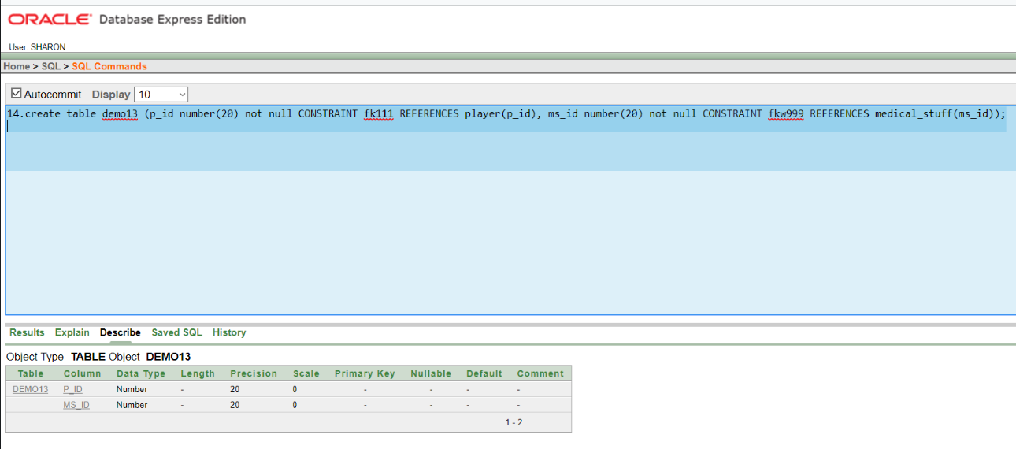

**Constraints**

1. alter table responsible_person add constraints fk_37643 foreign key(a_id) references account(a_id);
2. alter table responsible_person add constraints fk_67574 foreign key(p_id) references president(p_id);
3. alter table football_club add constraints fk_3777 foreign key(sc_id) references show_case(sc_id);
4. alter table football_club add constraints fk_4536 foreign key(t_id) references team(t_id);
5. alter table football_club add constraints fk_3543 foreign key(st_registration_id) references stadium(st_registration_id);
6. alter table president add constraints fk_9803 foreign key(c_id) references coach(c_id);
7. alter table show_case add constraints fkk_2544 foreign key (t_id) references team(t_id);
8. alter table player add constraints fk_3247 foreign key (a_id) references player_info1(a_id);
9. alter table player add constraints fk_2347 foreign key (fc_registration_number) references football_club(fc_registration_number);

**10**.alter table player add constraints fk_2344 foreign key (t_id) references team(t_id);

**11**.alter table player add constraints fk_3287 foreign key (c_id) references coach(c_id);

**12**. alter table stadium add constraints fk_3234 foreign key (s_id) references stuff(s_id);

**13**.alter table stuff add constraints fk_3464 foreign key (p_id) references player(p_id);

**Data Insertion**

1. **Account:**
2. insert into account(a_id , post, salary) values('17355','MANAGER','25000');
3. insert into account(a_id , post, salary) values('17356','ASSISTANT','30000');
4. insert into account(a_id , post, salary) values('17357','EXECUTIVE','35000');
5. insert into account(a_id , post, salary) values('17358','DIRECTOR','45000');

**5**.insert into account(a_id , post, salary) values('17359','ADVISOR','20000');

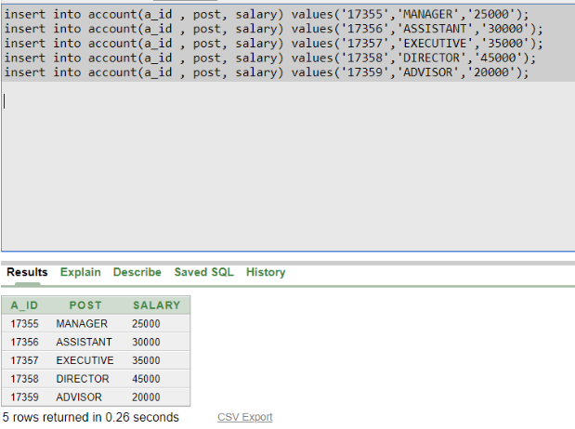

**2.Coach:**

1. insert into coach (c_id, c_name, salary, phone, address, nationality, hiredate )values('1345','JOY','60000','01536541912','DHANMON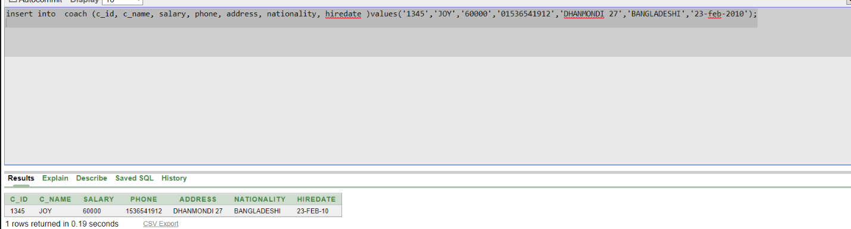DI 27','BANGLADESHI','23-feb-2010');

**3.Player information:**

* + - 1. insert into player_info1(a_id , salary, skill )values('543','50000','DRIBLING');
      2. insert into player_info1(a_id , salary, skill )values('667','40000','HEAD SHOT');
      3. insert into player_info1(a_id , salary, skill )values('555','35000','KICKING');
      4. insert into player_info1(a_id , salary, skill )values('432','55000','FREE KICK');
      5. insert into player_info1(a_id , salary, skill )values('123','50000','DRIBLING');

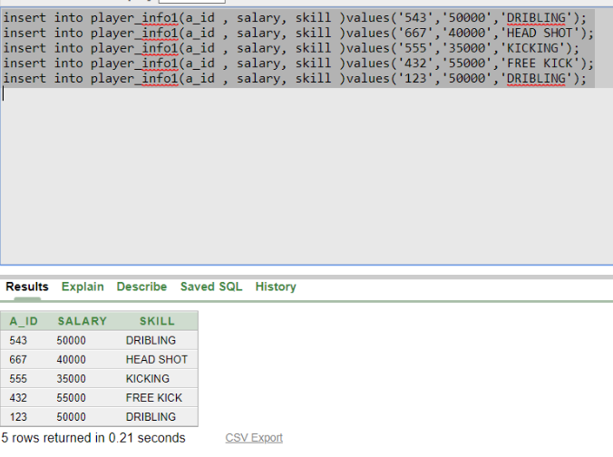

**4.Coach:**

**1.** insert into team(t_id, t_name, rank)values('45677','VICTORY','02');

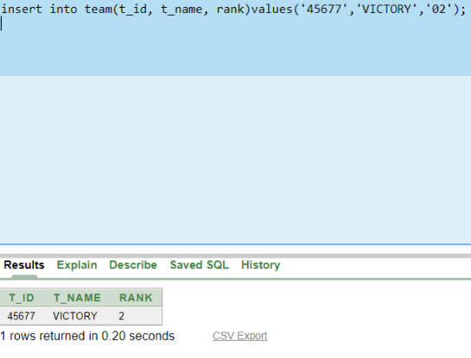

**5.Medical stuff:**

1. insert into medical_stuff (ms_id, ms_name, email , phone , salary , address, hiredate)values('432','SAIDUR','saidur@gmail.com','01876523409','40000','MIRPUR','01-apr-2011');
2. insert into medical_stuff (ms_id, ms_name, email , phone , salary , address, hiredate)values('104','ABIR','abir@gmail.com','01776523409','45000','NIKETON','06-jun-2012');
3. insert into medical_stuff (ms_id, ms_name, email , phone , salary , address, hiredate)values('345','PRANTO','pranto@gmail.com','01844523409','40000','MIRPUR','05-dec-2011');
4. insert into medical_stuff (ms_id, ms_name, email , phone , salary , address, hiredate)values('223','NAFIS','nafis@gmail.com','01876853409','30000','DHANMONDI','25-feb-2012');
5. insert into medical_stuff (ms_id, ms_name, email , phone , salary , address, hiredate)values('665','FARHAN','farhan@gmail.com','01876556709','40000','AZIMPUR','18-apr-2012');

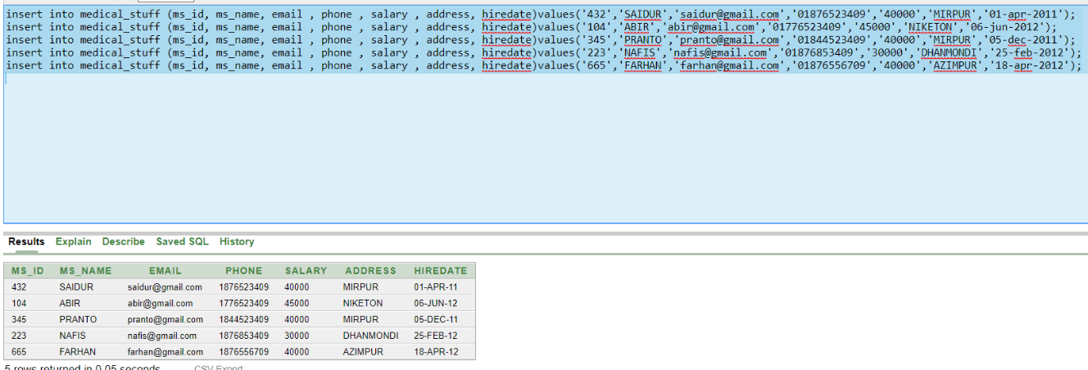

**6.Stuff:**

1. insert into stuff (s_id, s_name , email , phone, salary , address, hiredate)values('478','RAFIQ','rafiq@gmail.com','01967543271','25000','MALIBAGH','29-mar-2011');
2. insert into stuff (s_id, s_name , email , phone, salary , address, hiredate)values('847','ABUL','abul@gmail.com','01967546571','20000','MERUL BADDA','04-jul-2011');
3. insert into stuff (s_id, s_name , email , phone, salary , address, hiredate)values('136','NAHIYAN','nahiyan@gmail.com','01869143271','25000','NIKUNJO','16-jul-2011');
4. insert into stuff (s_id, s_name , email , phone, salary , address, hiredate)values('931','RIYAN','riyan@gmail.com','01578543271','20000','SHANTINOGOR','19-aug-2011');
5. insert into stuff (s_id, s_name , email , phone, salary , address, hiredate)values('666','ALIM','alim@gmail.com','01967993271','25000','GAZIPUR','05-nov-2011');

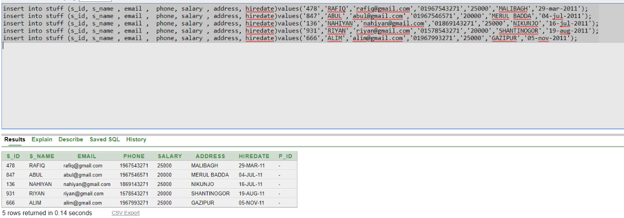

**7.Stadium:**

1. 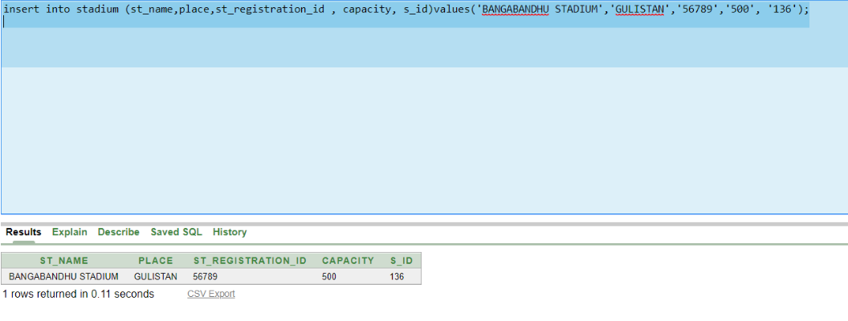insert into stadium (st_name,place,st_registration_id , capacity, s_id)values('BANGABANDHU STADIUM','GULISTAN','56789','500', '136');

**8.Showcase:**

* + - 1. insert into show_case (sc_name, sc_id, t_id)values('SHOWCASE','8974','45677');

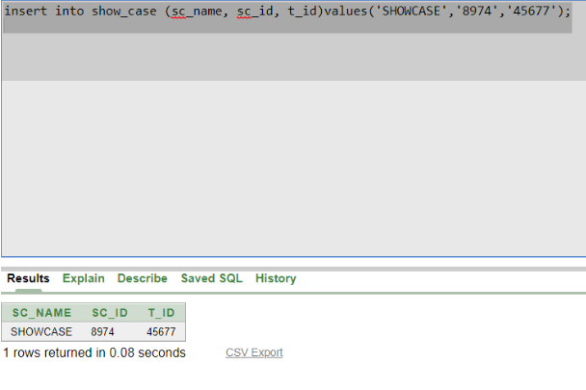

**9.Football Club:**

**1.** insert into football_club(fc_registration_number, fc_name, sc_id, t_id, st_registration_id)values('13579','UDOYON FOOTBALL CLUB','8974','45677', '56789');

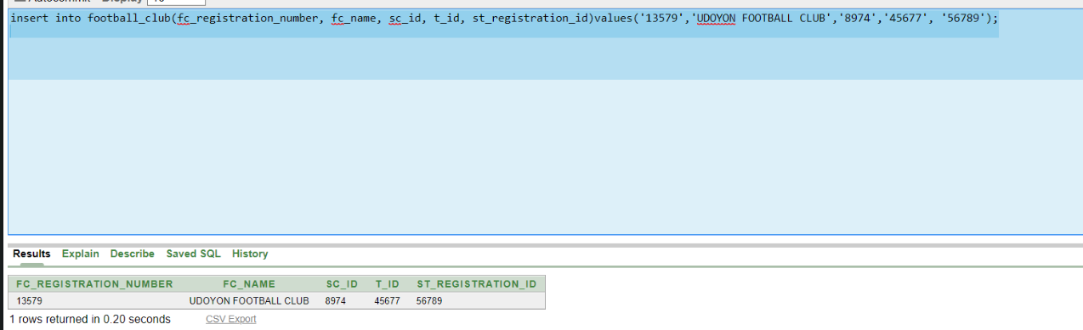

**10.Player**

1. insert into player(p_id, p_name, birthdate ,height, phone , nationality, hiredate,a_id,fc_registration_number,t_id,c_id)values('001','RAKIB','29-feb-1980','5.8','01846738219','BANGLADESHI','20-mar-2011','543','13579','45677','1345');
2. insert into player(p_id, p_name, birthdate ,height, phone , nationality, hiredate, a_id,fc_registration_number,t_id,c_id)values('023','HASAN','03-aug-1993','5.7','01946738219','BANGLADESHI','07-sep-2011','667','13579','45677','1345');
3. insert into player(p_id, p_name, birthdate ,height, phone , nationality, hiredate, a_id,fc_registration_number,t_id,c_id)values('045','MAHMUDUL','11-oct-1994','5.8','01846997219','BANGLADESHI','19-jan-2012','555','13579','45677','1345');
4. insert into player(p_id, p_name, birthdate ,height, phone , nationality, hiredate, a_id,fc_registration_number,t_id,c_id)values('039','DURJOY','31-aug-1997','5.9','01537270759','BANGLADESHI','21-april-2012','432','13579','45677','1345');
5. insert into player(p_id, p_name, birthdate ,height, phone , nationality, hiredate, a_id,fc_registration_number,t_id,c_id)values('076','JOY','01-feb-1985','5.7','01846767219','BANGLADESHI','06-jun-2012','123','13579','45677','1345');

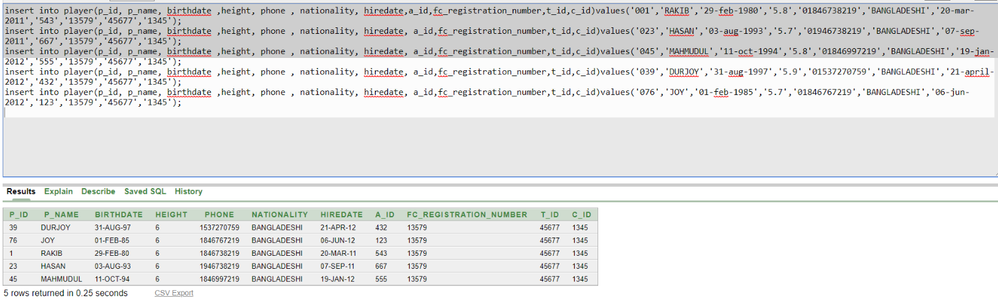

**11.President:**

1. insert into president(p_id ,p_name, salary, phone, email, address, c_id)values('98765','ABDULLAH','80000','01912449977','abdullah@gmail.com','GULSHAN 1','1345');

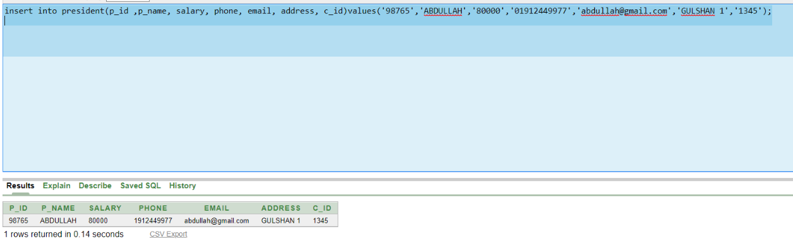

**12.Responsible Person:**

* + - 1. insert into responsible_person(rm_id, rm_name, phone , email, address,a_id,p_id)values('355','RAHIM','01733559921','rahim@gmail.com','BASHUNDHORA J BLOCK','17355','98765');
      2. insert into responsible_person(rm_id, rm_name, phone , email, address,a_id,p_id)values('358','KARIM','01733449921','karim@gmail.com','NIKUNJO','17356','98765');
      3. insert into responsible_person(rm_id, rm_name, phone , email, address,a_id,p_id)values('349','ABBAS','01736759921','abbas@gmail.com','NIKETON','17357','98765');
      4. insert into responsible_person(rm_id, rm_name, phone , email, address,a_id,p_id)values('359','KUDDUS','01922559921','kuddus@gmail.com','DHANMONDI 32','17358','98765');
      5. insert into responsible_person(rm_id, rm_name, phone , email, address,a_id,p_id)values('336','MOFIZ','01893559921','mofiz@gmail.com','BANANI','17359',

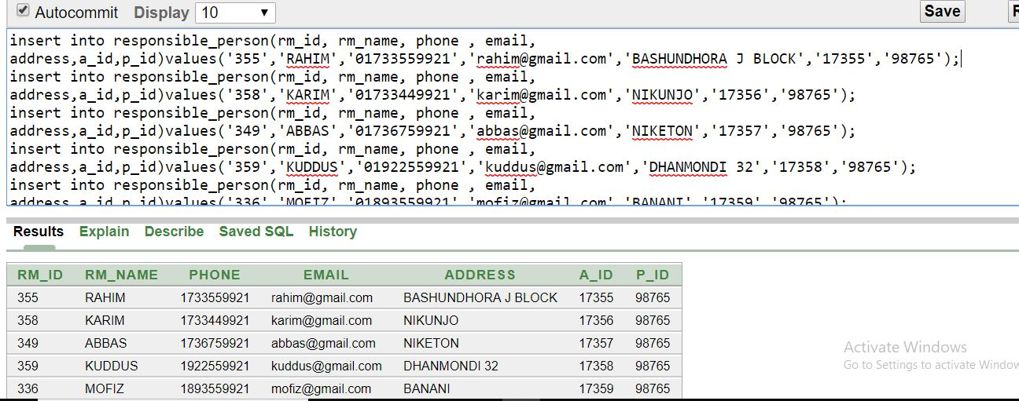address,a_id,p_id)values('336','MOFIZ','01893559921','mofiz@gmail.com','BANANI','17359',

**Query writing**

**Single Row Function:**

1**.Ques:**Display all data of player joy.

**Ans:**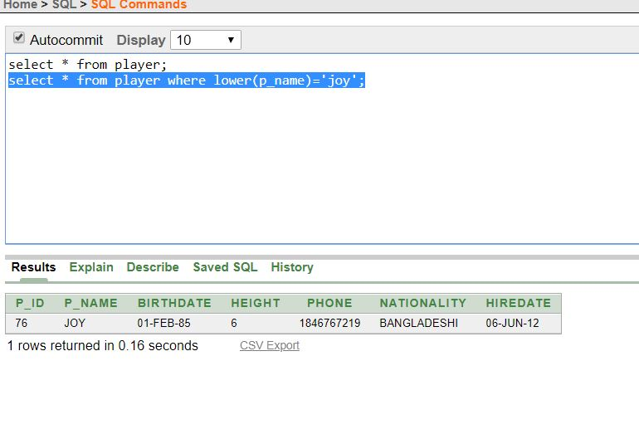

2.**Ques:**Display the hiredate of all player.

**Ans:**

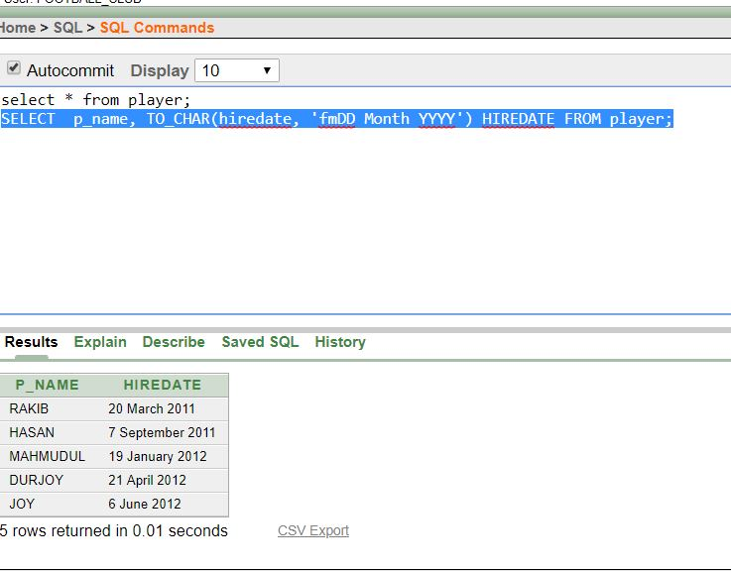

3.**Ques:** Display the SYSDATE-hiredate of ms_id=432;

**Ans:**

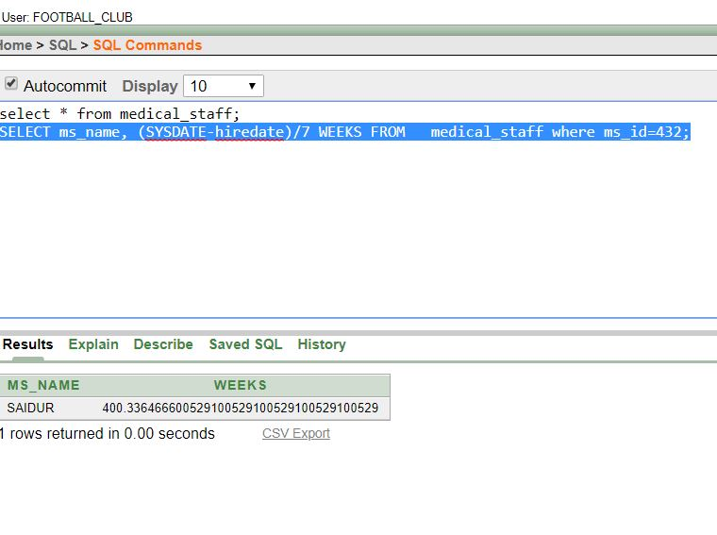

**Group Function:**

1.**Ques:**Display the sum of salaries grouped by medical stuff id.

**Ans:**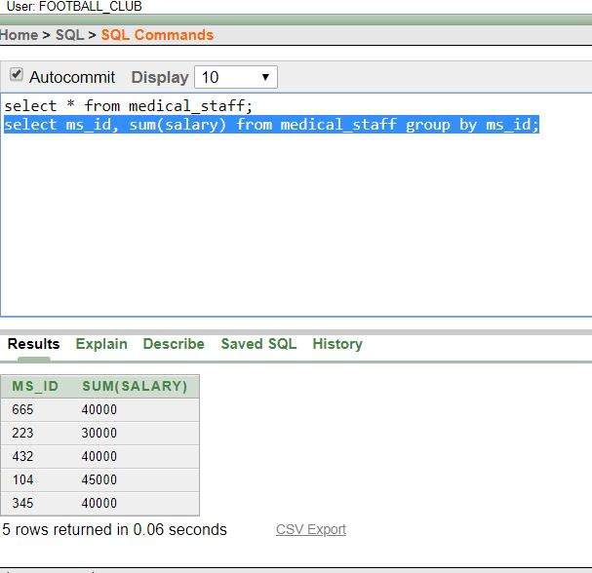

2.**Ques:**Find the AVG salary of medical stuff.

**Ans:**

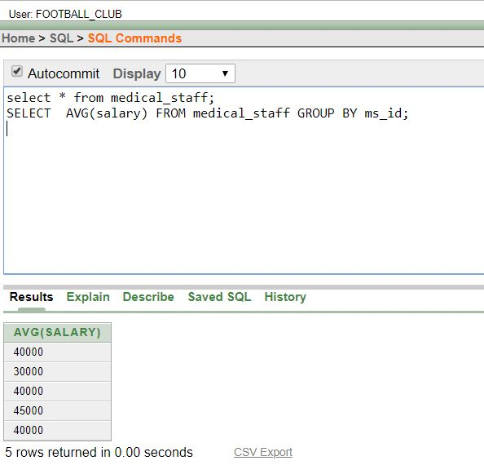

3.**Ques:**Find the MAX salary of medical stuff.

**Ans:**

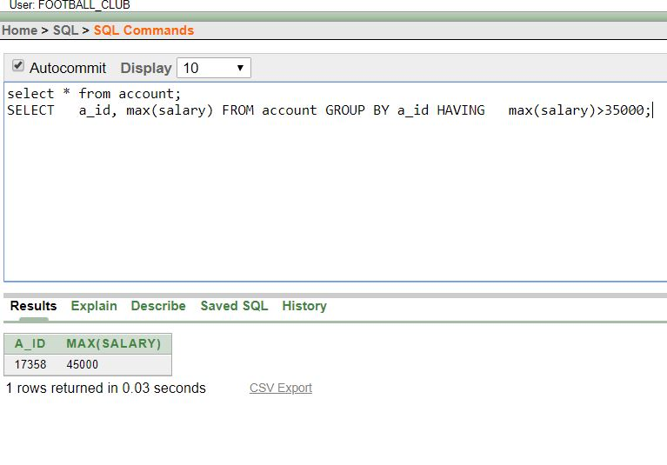

**Subquery:**

1.**Ques:**Display the id of account who earn more then ‘17355’.

**Ans:**

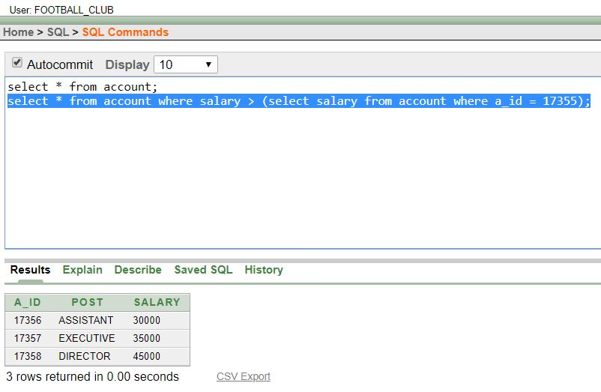

2.**Ques:**Display the id of account where post and salary are displayed.

**Ans:**

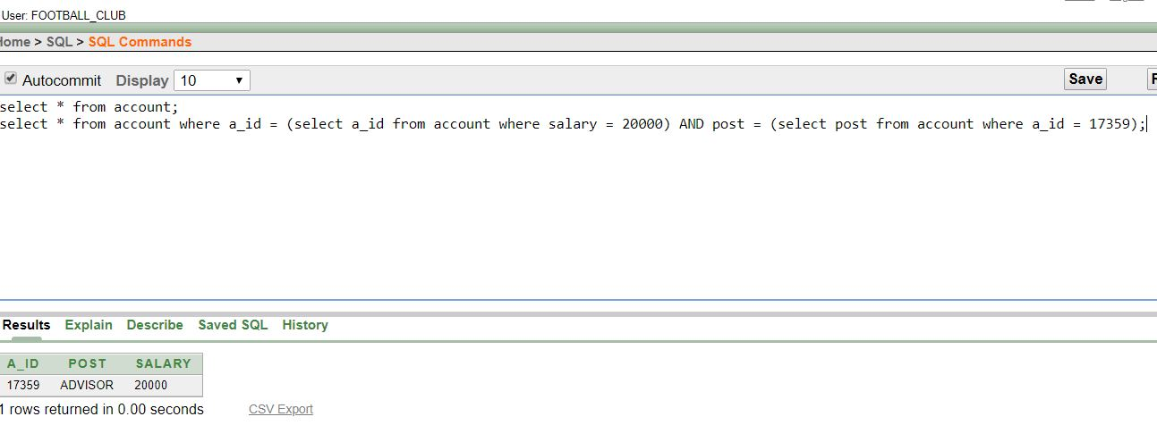

3.**Ques:**Display the id of player where player name id=’RAKIB’.

**Ans:**

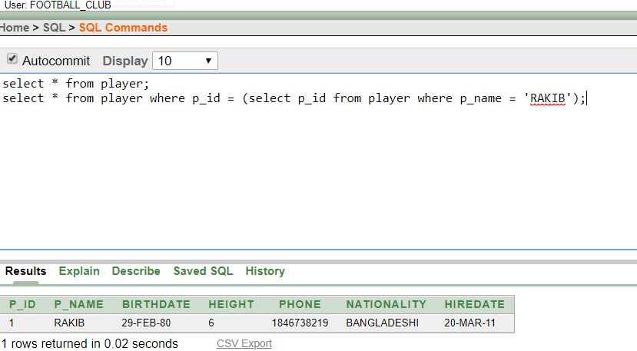

**Joining:**

1.**Ques:**Display the responsible person and id.

**Ans:**

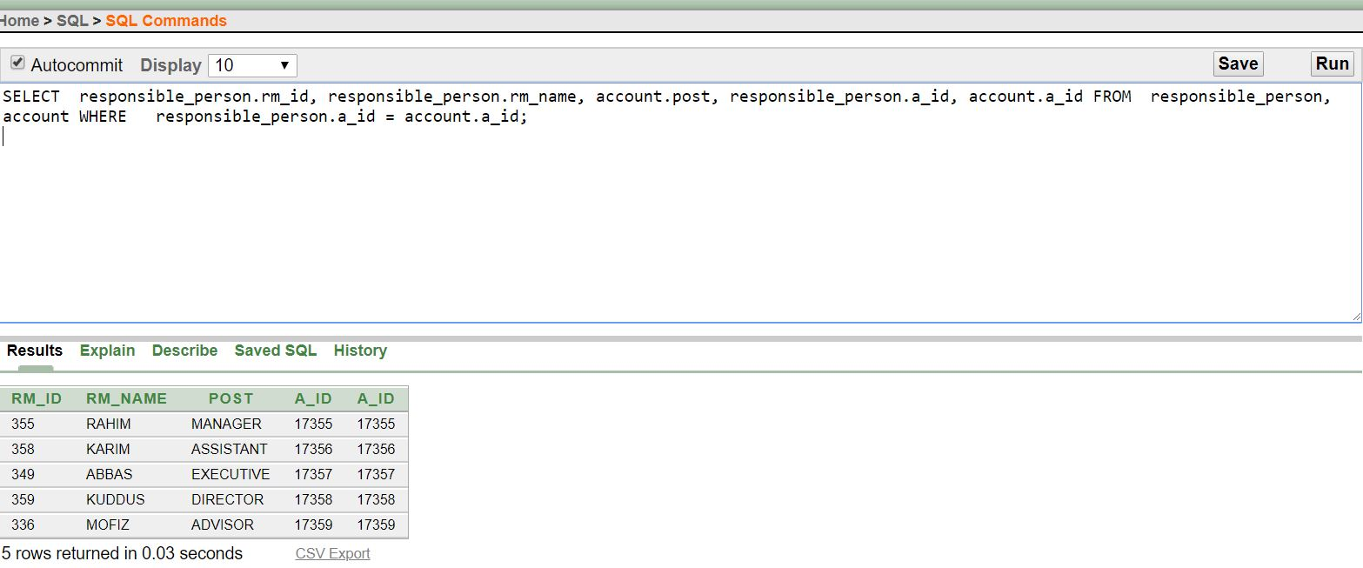

2.**Ques**:Display the player and id by joining.

**Ans:**

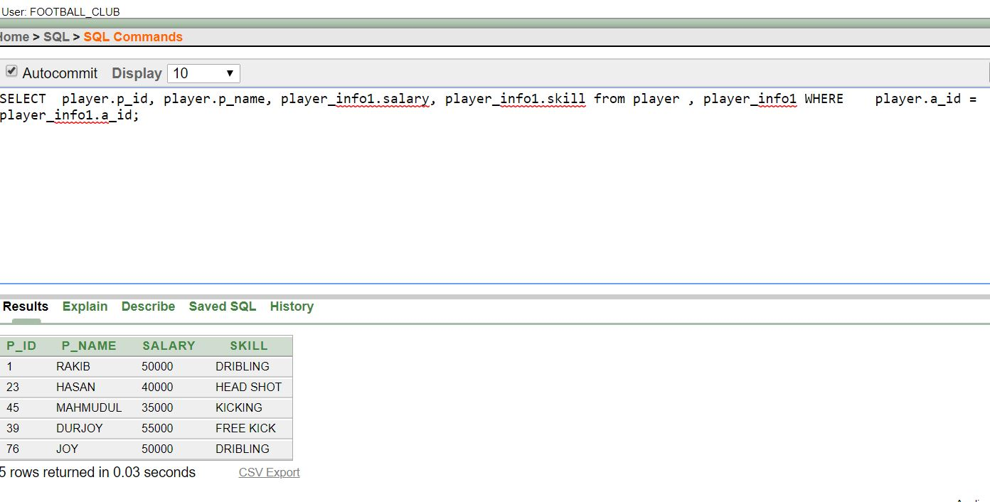

3.**Ques:**Display the responsible person and player by joining.

**Ans:**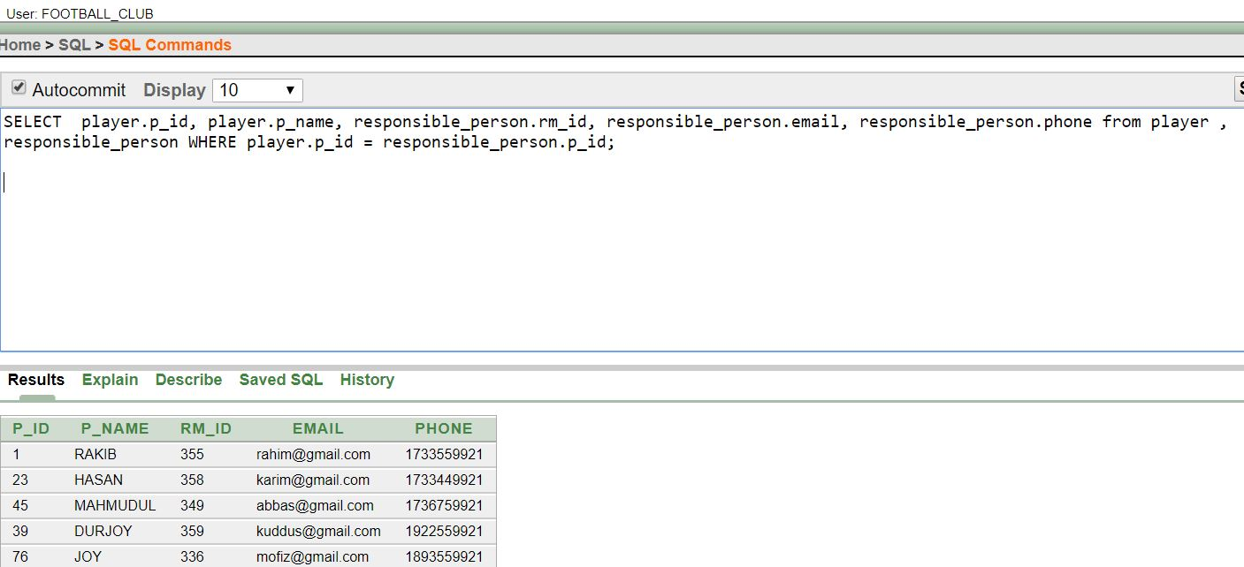

**Conclusion:**

After finishing this project we have learned many things like how we can make database,making scenario,normalization,query and lot of this .we all have enjoyed!

**THANK YOU**